Andrew Dykman – Lab 7 (With Screenshots)– Business Concepts for Application Developers – 8/15/2012

Task 1, 2a.)
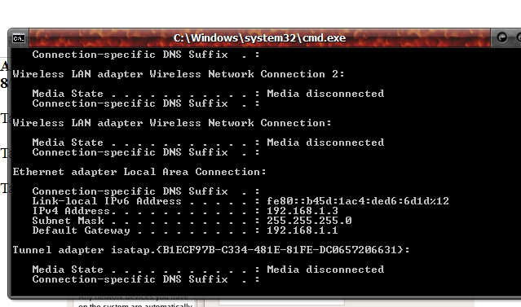
IP Address:192.168.1.1, Default Gateway: 192.168.1.1

Task 1, 8b.)
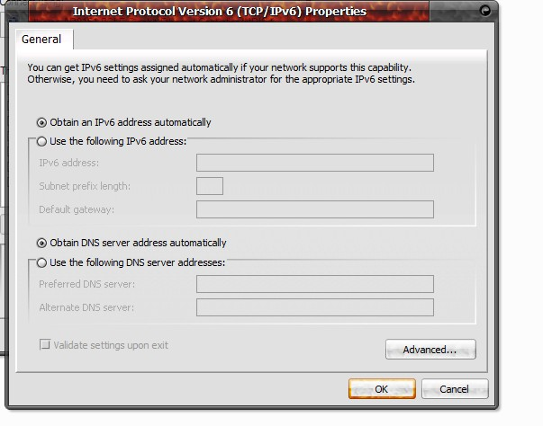
Automatically

Task 2, 6d.)
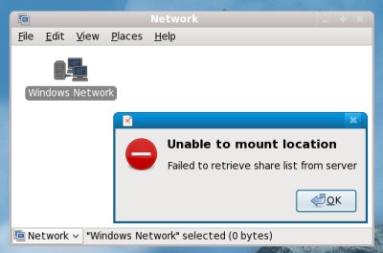
Windows Network

Task 2, 6d.)
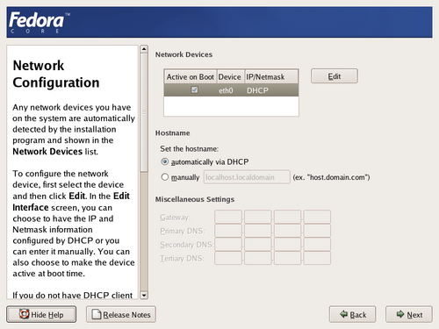
Automatically via DHCP

